APPLICATION FOR COURSE ENROLLMENT
Agriculture in responsibility for our common world
June 2021 – May 2022

Filled form to be sent by Email to: office@scoalaagricola.eu
Name of applicant: ……………….................................................................................................................
born on ......................., in ………...................................., country ............................................................
Address: ..................................................................................................................................................
..................................................................................................................................................................
……………………………………………………………………………………………………………………………………………………………
having nationality ….................................................................................................................................
employee, student within the company / university / faculty..................................................................
…………………………………………………………………………………………………………………………………………………………….
in the position / program of studies .........................................................................................................
I hereby request enrolment in the training courses held under the title project ,,Education and Research in the context of the digital and ecological transformation of agriculture in the Banat Region and Baden-Württemberg - towards resource efficiency and resilience.”, Module ..................................
...................................................................................................................................................................
Course period: .........................................................
Contact mobile phone: .......................................................
E-mail address: ...........................................................
Date: Name: Signature of the applicant:

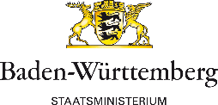
Project carried out with financial support from the State Ministry
of Baden-Württemberg.

